MISSION:  Our mission is to help achieve a quality child care system accessible to all Oklahoma families through community-based resource and referral services.  We provide many different services;  - Child care referrals and other parenting supports,  - Child care provider trainings technical assistance  - Various provider requested trainings to help increase the quality and availability of child care in Northwest Oklahoma. |  | CONTACT US  CDSA  Northwest Child Care  Resource & Referral  114 S. Independence  Enid, OK 73701  Telephone  580-234-3552  FAX: 580-234-3554  Street Address  City, ST ZIP Code |  |  | Northwest  Child Care Resource & Referral  114 S. Independence St.  Enid, OK 73701  - We provide child care referrals, support for families of young children, and free training and resources to child care providers across Northwest Oklahoma.  - 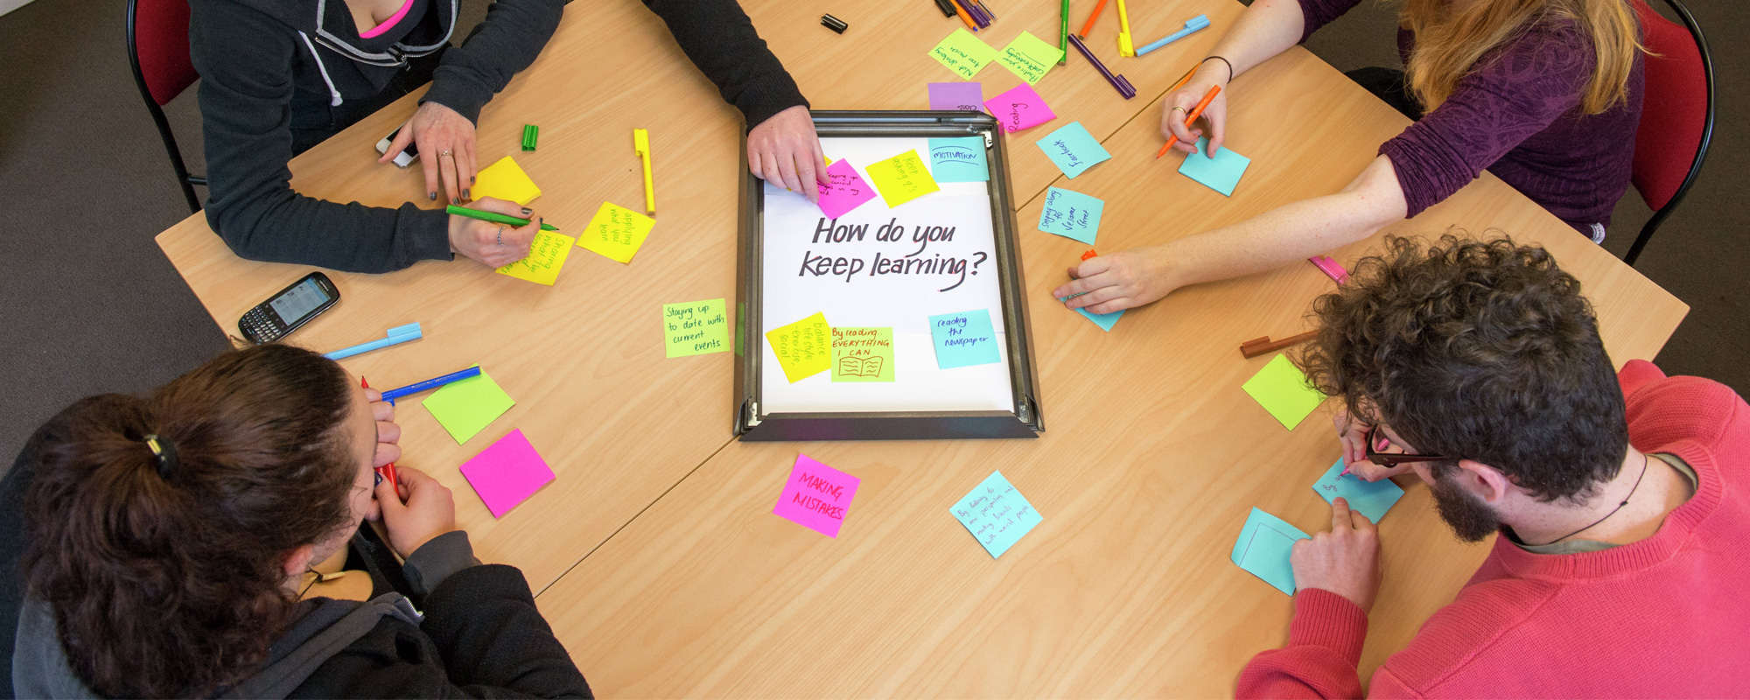

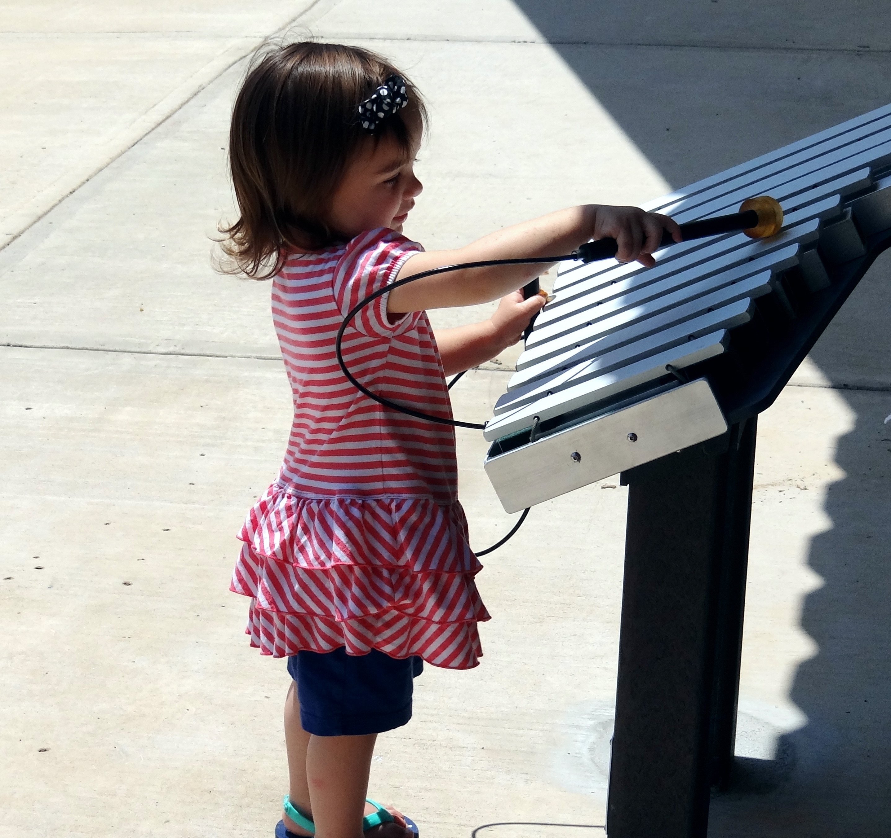  ABOUT US:  Northwest Child Care Resource & Referral is a program of Community Development Support Association (CDSA) since 1993. Child Care Resource and Referral provides services to 15 counties in northwestern Oklahoma. We are part of the Oklahoma Child Care Resource & Referral Association, a statewide network of eight regional agencies. The Association provides funding for services such as referral to families seeking care, training and coaching to licensed providers, and community outreach to inform leaders and employers about issues facing young children and working families. Funding is provided by the Oklahoma Department of Human Services, Child Care Services, through the Child Care Development Block Grant. | “Definitely will use many of their great ideas! Interactive and kept me moving!”  The Alphabet of Science training participant  Northwest Child Care Resource & Referral offers a variety of services to licensed child care providers such as:  - Training  - On-site coaching to infant/toddler teachers  - On-site coaching to preschool teachers  - On-site coaching to directors or owners on best business practices  - Resources to enhance a program or classroom  STAFF:  Early Childhood Coordinator:  Cheila Armour, cheila.armour@cdsaok.org  Consultants :  Stephanie Gray, stephanie.gray@cdsaok.org  Infant/Toddler Consultant:  Christy Taylor, christy.taylor@cdsaok.org  Business Consultant:  Natalya Ussery, Natalya.ussery@cdsaok.org | Serving 15 counties in  Northwest Oklahoma  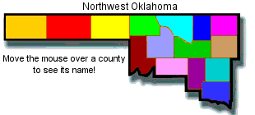  Cimarron, Texas, Beaver, Harper, Woods, Alfalfa, Grant, Ellis, Woodward, Major, Garfield, Dewey, Blaine, Kingfisher, Canadian  CONTACT US  CDSA  Northwest Child Care  Resource & Referral  114 S. Independence  Enid, OK 73701  Telephone  580-234-3552  FAX: 580-234-3554  https://www.nwokchildcare.org/

